ER Diagram for Proposed Database of MuzarMusic

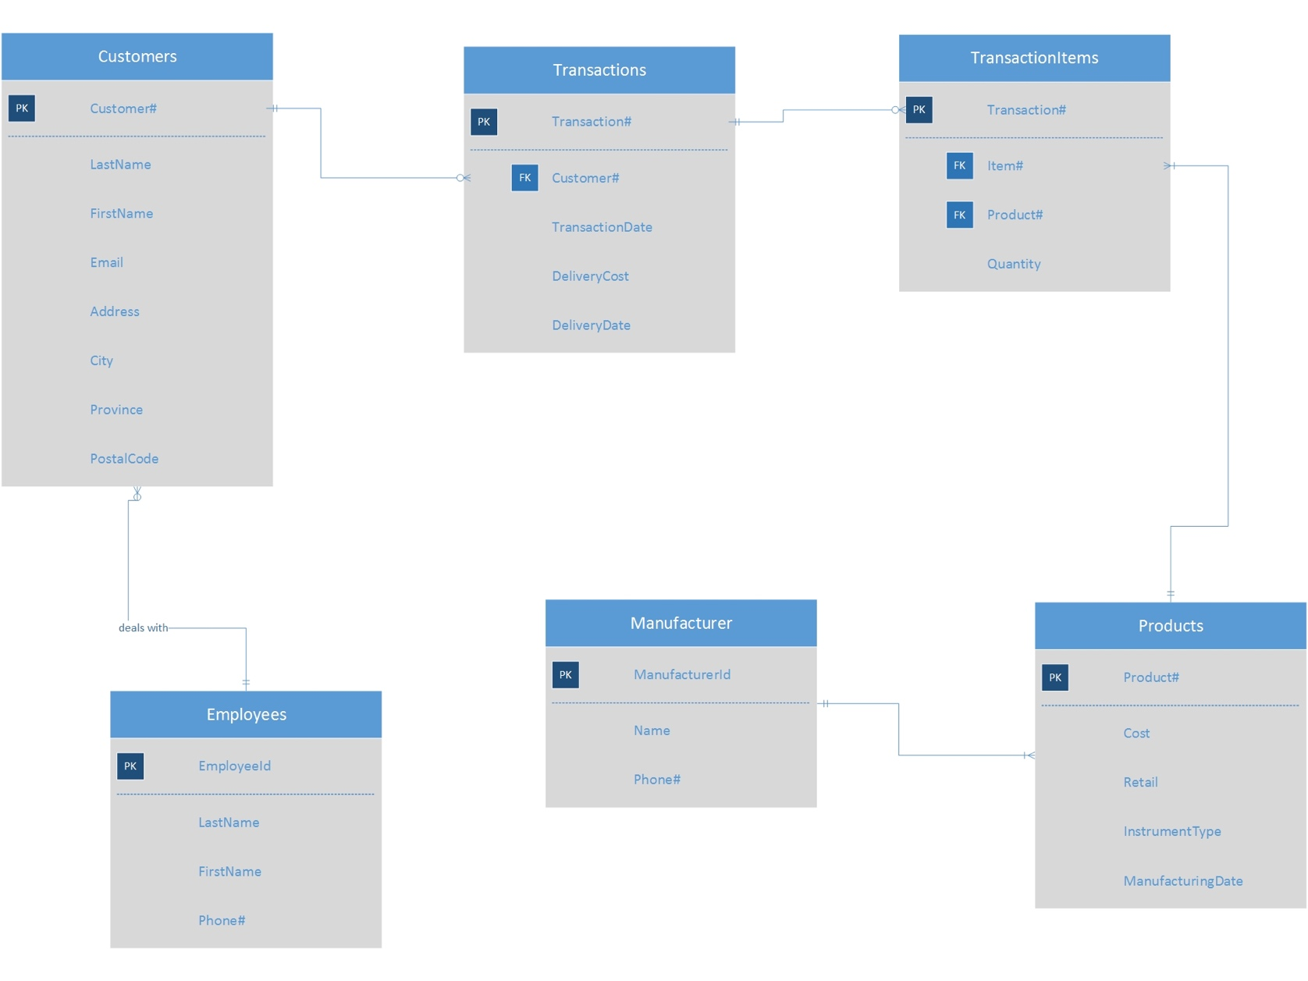Table Name: **Customers**

Table description: Customer’s Information

|  |  |  |  |  |  |
| --- | --- | --- | --- | --- | --- |
| Attribute | Description | Key Type | Data Type | Field length | Required |
| Customer# | Unique number assigned | Primary Key | Integer | 5 | Yes |
| LastName | Customer’s last name |  | Text | 20 | Yes |
| FirstName | Customer’s first name |  | Text | 20 | Yes |
| Email | Customer’s email address |  | Text | 30 | No |
| Address | Customer’s address |  | Text | 40 | Yes |
| City | Name of the province |  | Text | 20 | Yes |
| Province | Name of the city |  | Text | 20 | Yes |
| PostalCode | Postal Code |  | Text | 6 | Yes |

Table Name: **Transactions**

Table description: Transaction’s information with or without shipping

|  |  |  |  |  |  |
| --- | --- | --- | --- | --- | --- |
| Attribute | Description | Key Type | Data Type | Field length | Required |
| Transaction# | Unique number assigned | Primary Key | Integer | 6 | Yes |
| Customer# | Unique number assigned to the customer | Foreign Key | Integer | 5 | Yes |
| TransactionDate | Date of purchase |  | Date | 9 | Yes |
| DeliveryCost | Cost of delivery |  | Integer | 6 | No |
| DeliveryDate | Date of delivery |  | Date | 9 | No |

Table Name: **TransactionItems**

Table description: Contains the type, quantity of an item and populates each transaction

|  |  |  |  |  |  |
| --- | --- | --- | --- | --- | --- |
| Attribute | Description | Key Type | Data Type | Field length | Required |
| Transaction# | Unique number assigned | Primary Key  Foreign Key | Integer | 6 | Yes |
| Item# | Unique number assigned to the item | Primary Key | Integer | 7 | Yes |
| Product# | Unique number assigned to the product | Foreign Key | Integer | 8 | Yes |
| Quantity | Quantity of a particular product in a transaction |  | Integer | 3 | Yes |

Table Name: **Products**

Table description: Product’s information

|  |  |  |  |  |  |
| --- | --- | --- | --- | --- | --- |
| Attribute | Description | Key Type | Data Type | Field length | Required |
| Product# | Unique number assigned | Primary Key | Integer | 6 | Yes |
| Name | Given name of the product |  | Text | 40 | Yes |
| Cost | Cost to shelf the product |  | Integer | 6 | Yes |
| Retail | Selling price of the product |  | Integer | 6 | Yes |
| Instrument  Type | Category ie. strings, percussion, add-on, etc |  | Text | 20 | No |
| ManufacturingDate | Manufacturing date of the product |  | Date | 9 | No |

Table Name: **Manufacturers**

Table description: Product manufacturer’s information

|  |  |  |  |  |  |
| --- | --- | --- | --- | --- | --- |
| Attribute | Description | Key Type | Data Type | Field length | Required |
| ManufacturerId | Unique id assigned | Primary Key | Integer | 4 | Yes |
| Name | Name of the manufacturer |  | Text | 30 | Yes |
| Phone# | Contact number |  | Numeric | 10 | Yes |

Table Name: **Employees**

Table description: Employee’s information for that issues retail transactions, and for management review.

|  |  |  |  |  |  |
| --- | --- | --- | --- | --- | --- |
| Attribute | Description | Key Type | Data Type | Field length | Required |
| EmployeeId | Unique id assigned | Primary Key | Integer | 6 | Yes |
| LastName | Employee’s last name |  | Text | 20 | Yes |
| FirstName | Employee’s first name |  | Text | 20 | Yes |
| Phone# | Employee’s contact number |  | Numeric | 10 | No |